Lab 3.7 - Table Relationships

## Instructions

1. Answer the below question in the boxes.
2. Please submit the assignment after you finish.

## Open the Movies database

Follow the step illustrated in the lecture note to open the Movies database using DB Browser for SQLite. You should see 5 tables in the database.

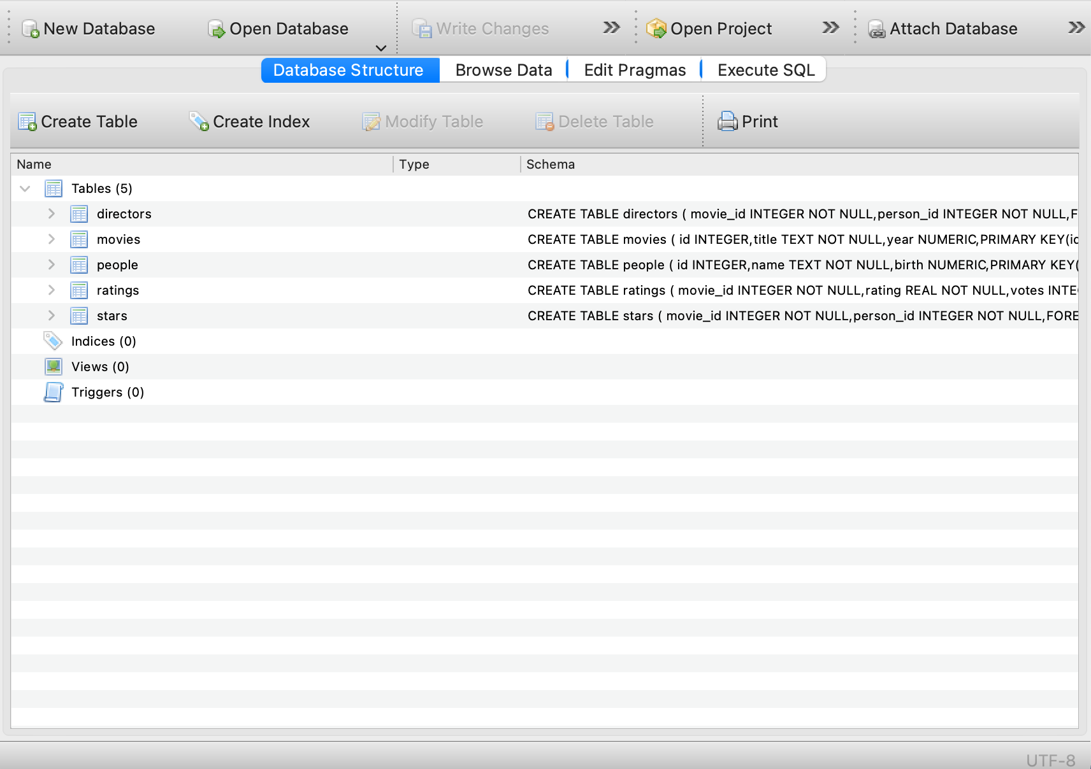

## 

## Database Study Exercises

Please try to answer the following questions by studying the movie databases. To be specific, please open up each of the tables and try to understand the meaning of each table and column.

If you need some more references or information, you can also read the following description:

| There are 5 tables in the database, including movies, ratings, directors, stars, and people.  The core of the database is “movies”, which stores all the movie entries. There is an id column in the movies table which serves as the unique identifier of the movies.  The ratings table stores the average ratings of each movies, and could be linked back to the movies table with the movie_id column.  Another important table is the people table. It stores the details of the people(actors and directors) who are related to at least one of the movies. Each person in the table got assigned with a unique key.  However, there is no information about who is acting or directing which movies from the people table. The relationships between “acting” and “directing” are stored in the “directors” and “stars” table. |
| --- |

**Questions**

1. What is the relationship between movies and ratings? Is it a one-to-one relationship, one-to-many relationship or many-to-many relationship?

|  |
| --- |

1. What is the relationship between movies - directors - people? What is the function of having the directors table?

|  |
| --- |

1. What is the primary key in the movies table?

|  |
| --- |

1. What is the primary key in the people table?

|  |
| --- |

1. What is the foreign key in the ratings table? What is the purpose of it?

|  |
| --- |

1. List another many-to-many relationship in the movies database that was not mentioned above yet. What are the tables involved?

|  |
| --- |

**- End of Assignment -**